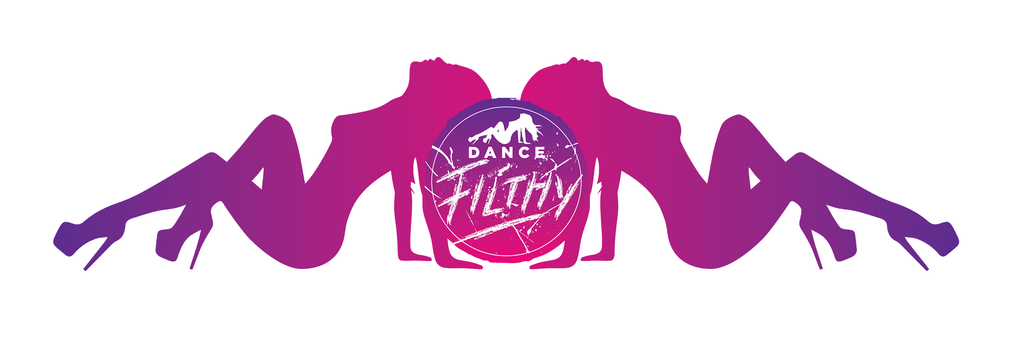

**VIDEO ENTRY GUIDELINES**

**Please read these guidelines carefully - your video entry MUST comply with these guidelines or it will not be judged**

**1.** Videos must be 2 - 3 minutes in length. Longer videos will not be watched beyond 3 minutes.

**2.** Video entries will be judged on presentation, pole skill and performance ability.

**3.** Videos MUST be on YouTube or Vimeo. Downloadable files are not allowed. Videos may be on unlisted setting in youtube, but not private.

**4.** The title of the video on YouTube must say that it is a Dance Filthy entry, and must have the entrant's name in the title, e.g. Michelle Shimmy's entry in Dance Filthy, 2019.

**5.** The description of the video on YouTube or Vimeo **must contain the entrant's proposed performance description​** (so that the judges can easily refer to it while watching).

- For example: ”In my proposed performance at Dance Filthy Sydney 2019, I will be portraying a nerdy school girl who desperately wants to prove she's not a young girl anymore bound by her books.

**6.** Videos **must not**​ be edited in any way and must be filmed in one single take (i.e. no splicing together of different clips).

**7.** Videos must be of good quality with sufficient lighting.

**8.** Only one video will be viewed per entrant, per category. Entrants cannot submit multiple videos, unless they are entering more than one category and wish to provide a different video for each category entered.

**9.** The video must show only the entrant performing. It is not acceptable to submit a group performance and ask the judges to identify the entrant in the group. Human props are allowed to be in the video if they are being used as human props.

**10.** It is strongly advised that competitors submit a video that matches the Dance Filthy criteria, i.e. it is advisable to enter a video of you doing a more sexy performance with floor work rather than a contemporary lyrical piece. This is so the judges can see that you are capable of “Dancing Filthy”. It is also important to make sure you have a balance between tricks and floorwork, and that you demonstrate that you have strong performance skills and have good stage presence, even if your video is filmed in a studio setting. The judges want to see that you are capable of engaging and connecting with an audience.