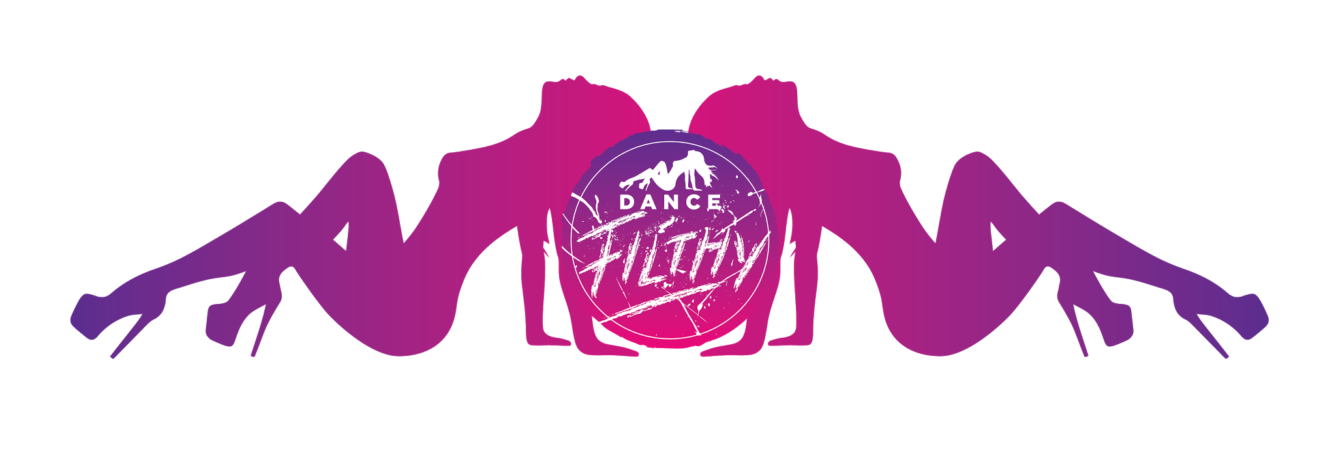

**Dance Filthy Competitor Rules**

**Eligibility**

1. Entry is open to anyone aged over 18 years,

2. Entry is open to all male and female competitors,

3. Entry in the Amateur, Semi Professional and Professional Division is by video entry

4. Levels are graded in accordance to the Australian National Competition Eligibility Standards, found here: <http://www.auspoledancersmag.com.au/competition-eligibility/>

5. Groups may enter into Semi Pro or Professional. They must enter into the category of the highest achieving performer in the group in accordance to the National Competition Eligibility Standards,

6. The Elite Performance Showcase is by invitation only.

**Entry**

Applicants are selected based on the video submitted. Videos must be a single take, and not clips edited together. Videos must be 3min max.

**Props, costume, etc**

1. Performers are permitted to use any props, sets, costuming, additional performers, sound effects, performance apparatus or footwear, provided that:
   1. the space allows for it physically;
   2. it is of a size that can be easily transported on a plane (so that international competitors are not disadvantaged); and
   3. it can be set up and completely removed in under 3 minutes.
2. If any props are to be used, performers must advise us by email.
3. Competitors are allowed to remove items of costume, down to g-string and pasties.
4. Glitter is not allowed. Competitors are welcome to instead use a large confetti.
5. All liquid, messy and dirty props will be required to be used on stage over a drop sheet and must be approved.

**Performance**

1. You must submit a description of your performance. You must notify the Organisers by email of any significant changes to your planned performance no later than 2 weeks before the date of the final. Any significant changes to your planned performance after that date are not permitted without Organiser approval.

2. At Dance Filthy, we are looking for fun, wild, sexy and creative routines. We want you to entertain, surprise and delight your audience... but not frighten them! We are not looking for vulgar or offensive shows. It’s a fine line... If you aren’t sure, please call or email us to discuss your ideas.

**Competitors and performance**

1. Competitors must arrive at the venue at their allocated time on the day for rehearsals.
2. Competitors must ensure they have warmed up and stretched properly prior to performing.
3. Competitors must not consume alcohol or any prohibited substance prior to performing.
4. Performances must be between 3 and 4 min long. All performances that exceed 4 minutes will have their music cut on the night and lose points.
5. Poles will be 40mm brass competition-grade X-Poles. The default setting is stage left spin and stage right static. You have the option to have both poles on spin or static.
6. Poles can be cleaned with a dry wipe, metho wipe or dry hands. All other grip aids must not be put directly onto the pole but may be applied to the performers body.

**Criteria and judging**

1. There will be 3-4 judges.

2. Competitors will be judged on the following criteria:

* **Pole tricks** (skillful execution and technique): 10 points
* **Floor work and dance**: 10 points
* **Costume**: 10 points
* **“Filthy Factor”** (stage presence, sexiness, creativity, engagement with audience, entertainment and originality): 10 points

**Waiver of liability**

1. The competitors acknowledge and accept that Pole Dance Academy, its owners, staff (the Organisers) and The (Venue) staff and owners (“Venue Related Parties”) are not responsible for injury or damage resulting from participation in the competition, including the competitors’ arrival and departure from the competition.
2. The competitors acknowledge that pole dance is a dangerous activity and as such the competitors voluntarily accept the risks associated in participating in the competition.
3. The competitors waive to the full extent permitted by law all legal rights of action against and fully releases the Venue and Venue Related Parties and the Organisers and Related Parties for the loss, damages, or injury howsoever arising out of or in relation to the participation by the competitors in the activities conducted or organised by the Organisers and Related Parties including without limitation, liability for any negligent or tortious act or omission, breach of duty, breach of contract or breach of statutory duty on the part of the Organisers or Related Parties.

**Photos/videos/livestream**

1. Competitors are aware that they will be photographed or videoed during their performance, and that the event may be livestreamed.
2. The competitor acknowledges that photos or video may be published by the Organisers.
3. The competitor releases all rights or claims over any photos or videos, and acknowledges that such material is the property of and can be used by the Organisers for promotional or other uses, without compensation to the competitor.
4. Competitors may film their own performances and post 1 minute clips to social media. Competitors may post their full performances publicly 8 weeks after the event is over, but not before.